centralindia
Standard_D2as_v5
az vm list-skus --size Standard_B2ms --output table

Student Lab Manual
Azure VM, Kafka & .NET Microservices
Real-Time Payment Feedback with Bicep, Kafka KRaft and .NET 8

Estimated Duration: 2.5 hours

Lab Overview
In this lab you will provision a Linux VM on Azure using a Bicep template — an Infrastructure as Code approach that eliminates manual installation steps. Once the VM is ready, you will build two .NET 8 applications directly inside the VM:

- PaymentProcessor — an ASP.NET Core WebAPI that receives a payment request, randomly approves or declines it (like a mock payment gateway), and publishes the result to a Kafka topic.
- PaymentSimulator — a console app that continuously sends random payment requests to the WebAPI, and simultaneously reads results from Kafka, displaying them in real time with colour-coded output.

Architecture

Architecture
PaymentSimulator (Console App)
┌────────────────────────────────────────────────────────┐
│ [Producer Thread] → POST /api/payment/process │
│ │ │
│ PaymentProcessor (WebAPI) │
│ │ ProduceAsync() │
│ ▼ │
│ Kafka Topic: payment-events │
│ │ │
│ [Consumer Thread] ← Consume() │
│ [OK] APPROVED / [--] DECLINED │
└────────────────────────────────────────────────────────┘
All running on one Azure VM (Ubuntu 22.04, Standard_B2ms)

What You Will Learn
- How to write and deploy a Bicep template with a Custom Script Extension
- How Kafka works in KRaft mode (no ZooKeeper)
- How to produce and consume messages using Confluent.Kafka for .NET
- How the producer / consumer pattern enables real-time event streaming

Prerequisites Checklist
Confirm each item before starting:

- Azure subscription with Contributor role assigned
- Azure CLI installed and signed in — run az account show to confirm
- Windows Command Prompt (cmd.exe) or Windows Terminal
- SSH client available — test by typing ssh in cmd.exe (should show usage, not an error)
- A text editor — Notepad, VS Code, or any editor that can save plain text files

Part 1: Provision Infrastructure with Bicep
INFO
Bicep is Azure's Infrastructure as Code language. Instead of clicking through the portal,
you describe your resources in a .bicep file and Azure creates them.

In this lab the Bicep template also attaches a Custom Script Extension — a mechanism
that runs a bash script on the VM automatically after it is created. The script installs
Java 17, .NET 8 SDK, and Apache Kafka 3.7. By the time deployment finishes, everything
is installed and Kafka is already running as a background service.

Step 1.1 — Set Variables
Open a Command Prompt window. Set these variables — they are used in all subsequent commands.

CMD (Windows Command Prompt)
set RG=kafka-lab-rg
set LOCATION=eastus
set VM_NAME=kafka-lab-vm
set ADMIN_USER=azureuser
set ADMIN_PASS=KafkaLab@2024!
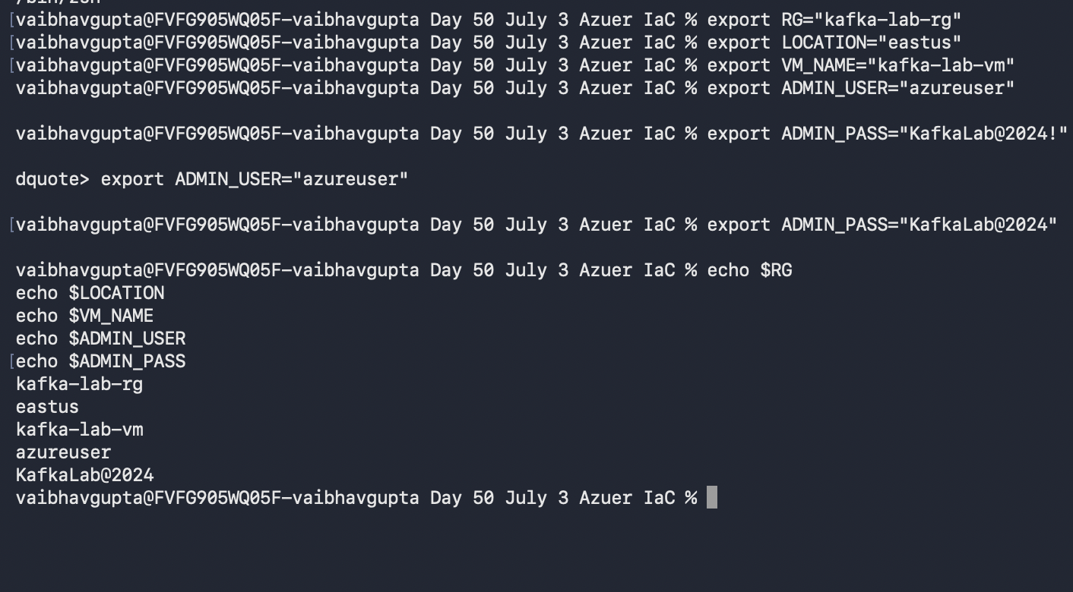
RECORD YOUR VALUES
RG = | kafka-lab-rg
LOCATION = | centralindia
ADMIN_PASS = | KafkaLab@2024

Step 1.2 — Create Resource Group

CMD (Windows Command Prompt)
az group create --name %RG% --location %LOCATION%
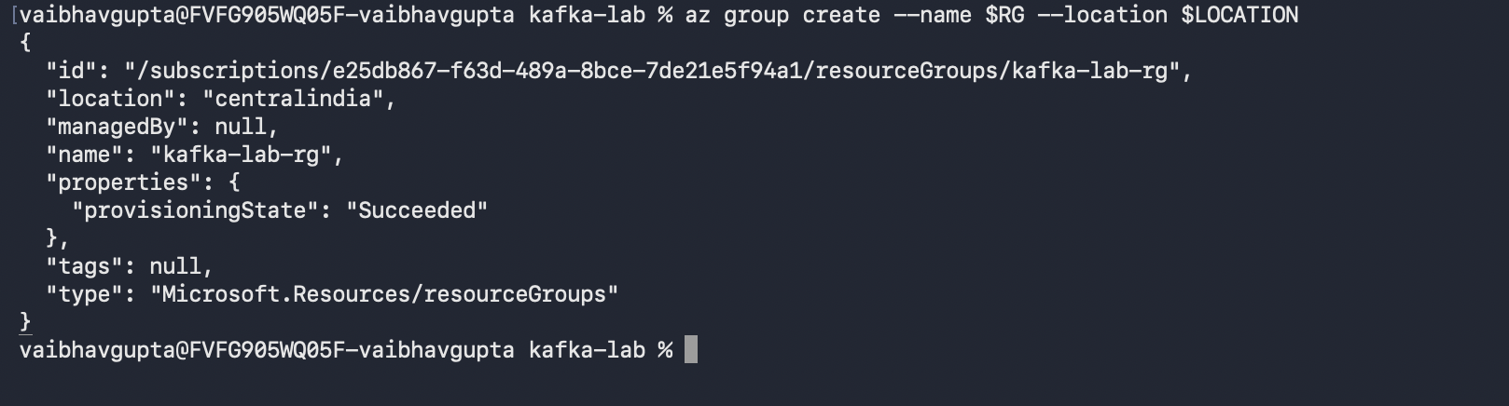

Step 1.3 — Create Project Folder

CMD (Windows Command Prompt)
mkdir %USERPROFILE%\kafka-lab
cd %USERPROFILE%\kafka-lab

Step 1.4 — Create main.bicep
Open a text editor and save the following as main.bicep inside the kafka-lab folder:

BICEP (main.bicep)
param location string = 'eastus'
param vmName string = 'kafka-lab-vm'
param adminUsername string = 'azureuser'

@secure()
param adminPassword string

param vmSize string = 'Standard_B2ms'

var nsgName = '${vmName}-nsg'
var vnetName = '${vmName}-vnet'
var subnetName = 'default'
var publicIpName = '${vmName}-pip'
var nicName = '${vmName}-nic'

resource nsg 'Microsoft.Network/networkSecurityGroups@2023-04-01' = {
name: nsgName
location: location
properties: {
securityRules: [{
name: 'AllowSSH'
properties: {
priority: 1000
protocol: 'Tcp'
access: 'Allow'
direction: 'Inbound'
sourceAddressPrefix: '*'
sourcePortRange: '*'
destinationAddressPrefix: '*'
destinationPortRange: '22'
}
}]
}
}

resource vnet 'Microsoft.Network/virtualNetworks@2023-04-01' = {
name: vnetName
location: location
properties: {
addressSpace: { addressPrefixes: ['10.0.0.0/16'] }
subnets: [{
name: subnetName
properties: { addressPrefix: '10.0.0.0/24', networkSecurityGroup: { id: nsg.id } }
}]
}
}

resource publicIp 'Microsoft.Network/publicIPAddresses@2023-04-01' = {
name: publicIpName
location: location
sku: { name: 'Standard' }
properties: { publicIPAllocationMethod: 'Static' }
}

resource nic 'Microsoft.Network/networkInterfaces@2023-04-01' = {
name: nicName
location: location
properties: {
ipConfigurations: [{
name: 'ipconfig1'
properties: {
subnet: { id: '${vnet.id}/subnets/${subnetName}' }
publicIPAddress: { id: publicIp.id }
}
}]
}
}

resource vm 'Microsoft.Compute/virtualMachines@2023-07-01' = {
name: vmName
location: location
properties: {
hardwareProfile: { vmSize: vmSize }
osProfile: {
computerName: vmName
adminUsername: adminUsername
adminPassword: adminPassword
}
storageProfile: {
imageReference: {
publisher: 'Canonical'
offer: '0001-com-ubuntu-server-jammy'
sku: '22_04-lts-gen2'
version: 'latest'
}
osDisk: {
createOption: 'FromImage'
managedDisk: { storageAccountType: 'StandardSSD_LRS' }
}
}
networkProfile: { networkInterfaces: [{ id: nic.id }] }
}
}

resource setup 'Microsoft.Compute/virtualMachines/extensions@2023-07-01' = {
parent: vm
name: 'setup-kafka'
location: location
properties: {
publisher: 'Microsoft.Azure.Extensions'
type: 'CustomScript'
typeHandlerVersion: '2.1'
autoUpgradeMinorVersion: true
settings: {}
protectedSettings: {
script: base64(loadTextContent('setup.sh'))
}
}
}

output publicIpAddress string = publicIp.properties.ipAddress
output sshCommand string = 'ssh ${adminUsername}@${publicIp.properties.ipAddress}'
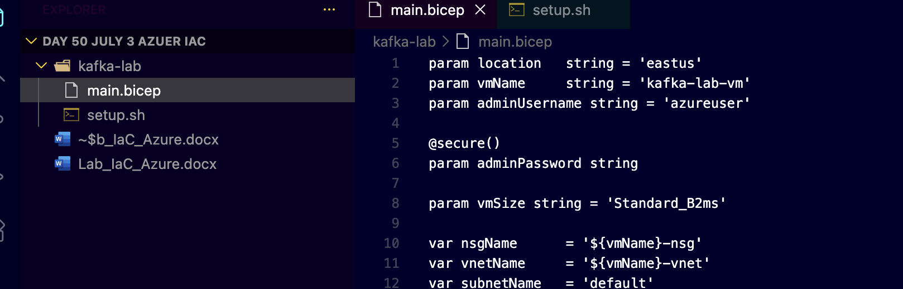

Step 1.5 — Create setup.sh
In the same kafka-lab folder, create a file called setup.sh with the following content. This is the script that installs everything on the VM automatically.

BASH SCRIPT (setup.sh)
#!/bin/bash
set -e
exec > /var/log/kafka-setup.log 2>&1

echo "=== Kafka Lab Setup Started ==="
date

# 1. System packages
apt-get update -y
apt-get install -y openjdk-17-jdk wget curl

# 2. Set JAVA_HOME system-wide
echo "JAVA_HOME=/usr/lib/jvm/java-17-openjdk-amd64" >> /etc/environment
export JAVA_HOME=/usr/lib/jvm/java-17-openjdk-amd64

# 3. Install .NET 8 SDK
wget https://packages.microsoft.com/config/ubuntu/22.04/packages-microsoft-prod.deb \
-O /tmp/ms-prod.deb
dpkg -i /tmp/ms-prod.deb
apt-get update -y
apt-get install -y dotnet-sdk-8.0

# 4. Download and extract Kafka 3.7.0
cd /opt
wget https://archive.apache.org/dist/kafka/3.7.0/kafka_2.13-3.7.0.tgz -O kafka.tgz
tar -xzf kafka.tgz
mv kafka_2.13-3.7.0 kafka
rm kafka.tgz

# 5. Format KRaft storage (single-node, no ZooKeeper)
KAFKA_UUID=$(JAVA_HOME=$JAVA_HOME /opt/kafka/bin/kafka-storage.sh random-uuid)
JAVA_HOME=$JAVA_HOME /opt/kafka/bin/kafka-storage.sh format \
-t "$KAFKA_UUID" \
-c /opt/kafka/config/kraft/server.properties

# 6. Create systemd service
cat > /etc/systemd/system/kafka.service << EOF
[Unit]
Description=Apache Kafka (KRaft Mode)
After=network.target

[Service]
Type=simple
User=root
Environment=JAVA_HOME=/usr/lib/jvm/java-17-openjdk-amd64
ExecStart=/opt/kafka/bin/kafka-server-start.sh /opt/kafka/config/kraft/server.properties
ExecStop=/opt/kafka/bin/kafka-server-stop.sh
Restart=on-failure
RestartSec=10

[Install]
WantedBy=multi-user.target
EOF

systemctl daemon-reload
systemctl enable kafka
systemctl start kafka

# 7. Wait for Kafka then create the topic
MAX_WAIT=90; WAITED=0
until JAVA_HOME=$JAVA_HOME /opt/kafka/bin/kafka-topics.sh \
--list --bootstrap-server localhost:9092 > /dev/null 2>&1; do
[ $WAITED -ge $MAX_WAIT ] && echo "ERROR: Kafka timeout" && exit 1
echo "Waiting for Kafka... (${WAITED}s elapsed)"
sleep 5; WAITED=$((WAITED+5))
done

JAVA_HOME=$JAVA_HOME /opt/kafka/bin/kafka-topics.sh \
--create --topic payment-events \
--bootstrap-server localhost:9092 \
--partitions 1 --replication-factor 1

echo "=== Setup Complete ===" && date
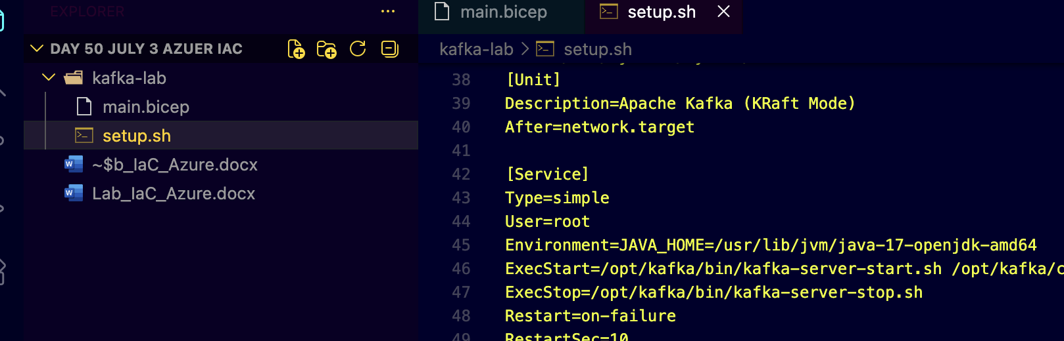

Step 1.6 — Deploy the Bicep Template
Make sure you are in the kafka-lab folder, then run:

CMD (Windows Command Prompt)
cd %USERPROFILE%\kafka-lab

az deployment group create ^
--resource-group %RG% ^
--name kafka-deploy ^
--template-file main.bicep ^
--parameters adminPassword="%ADMIN_PASS%"

INFO
This deployment takes approximately 10-14 minutes. Azure is:
1. Creating the VM, VNet, NSG, NIC and public IP (~2-3 min)
2. Running setup.sh via the Custom Script Extension (~8-10 min)
setup.sh installs Java, .NET SDK, and Kafka — then starts the Kafka service.

You will see "Running..." in the terminal while it works. When it finishes,
the output section shows publicIpAddress and sshCommand.

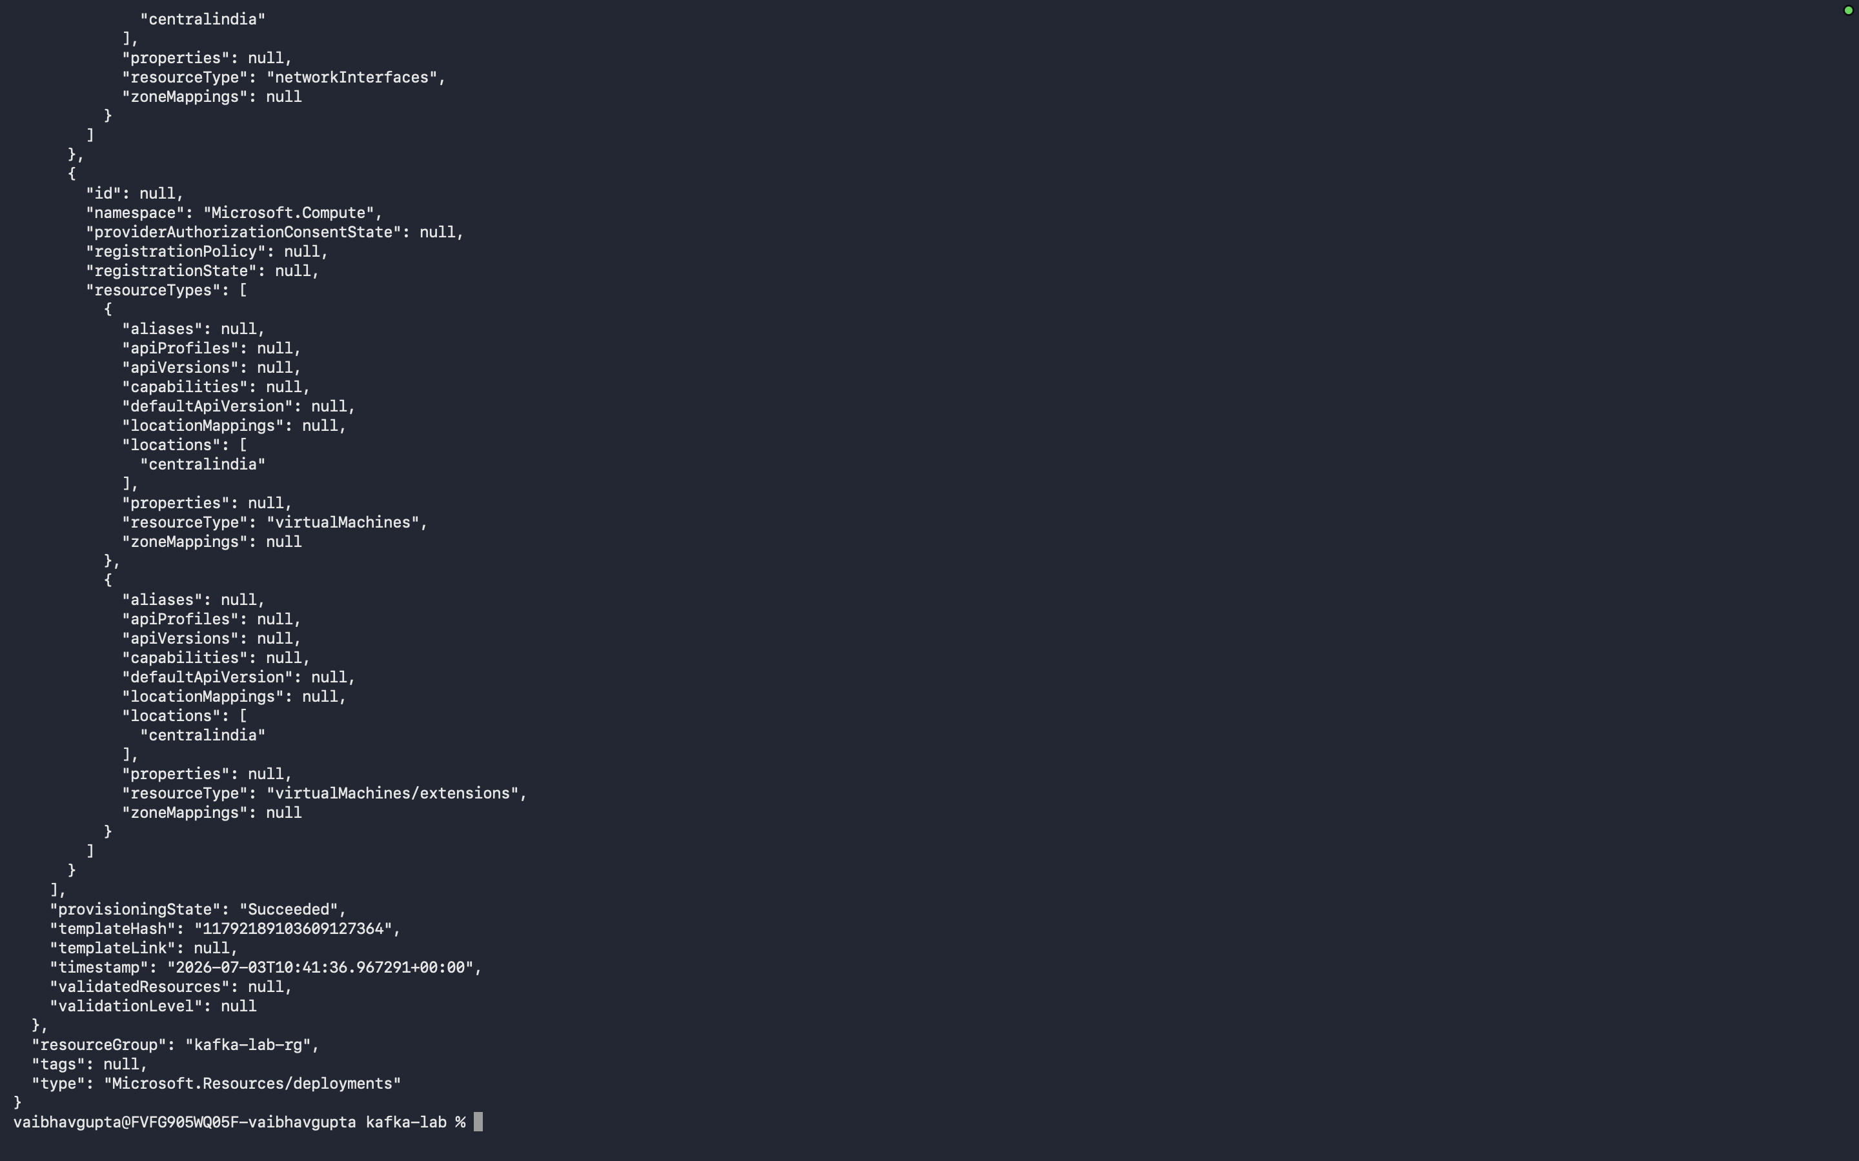

Step 1.7 — Capture the VM IP Address
When deployment finishes, capture the public IP from the outputs:

CMD (Windows Command Prompt)
for /f "delims=" %a in ('az deployment group show ^
--resource-group %RG% --name kafka-deploy ^
--query "properties.outputs.publicIpAddress.value" -o tsv') do set VM_IP=%a

echo VM IP: %VM_IP%

RECORD YOUR VALUES
VM_IP = | 74.225.170.255

Step 1.8 — Connect to the VM via SSH

CMD (Windows Command Prompt)
ssh %ADMIN_USER%@%VM_IP%

(Type yes to accept the host key fingerprint)
(Enter password: KafkaLab@2024)

INFO
You are now INSIDE the Linux VM. Your prompt changes to:
azureuser@kafka-lab-vm:~$

Everything from here until Part 4 runs in this SSH session.
Linux commands are case-sensitive — type them exactly as shown.

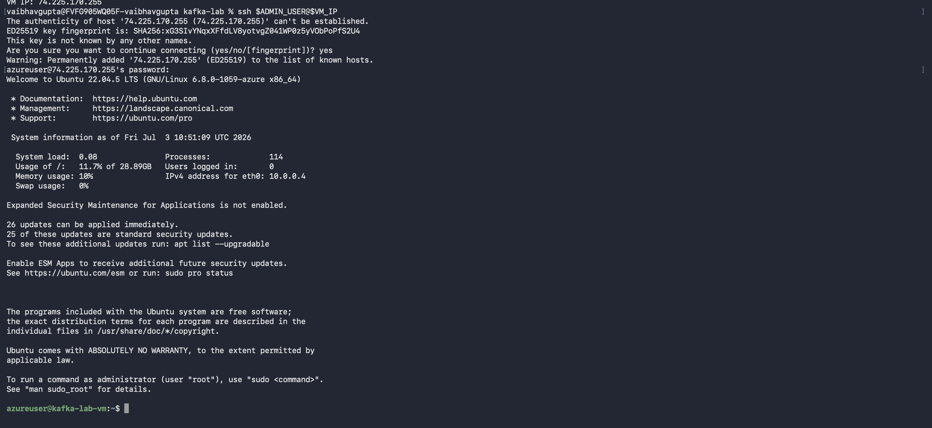

Step 1.9 — Verify the Stack
Confirm Java, .NET, and Kafka are all ready:

BASH (SSH — Linux VM)
# Check Kafka service status
systemctl status kafka --no-pager

# Check Java version
java -version

# Check .NET version
dotnet --version

# List Kafka topics — should show: payment-events
/opt/kafka/bin/kafka-topics.sh --list --bootstrap-server localhost:9092

RECORD YOUR VALUES
Java version: | openjdk version "17.0.19" 2026-04-21
.NET version: | SDK Version: 8.0.422
Kafka topics listed: | payment-events

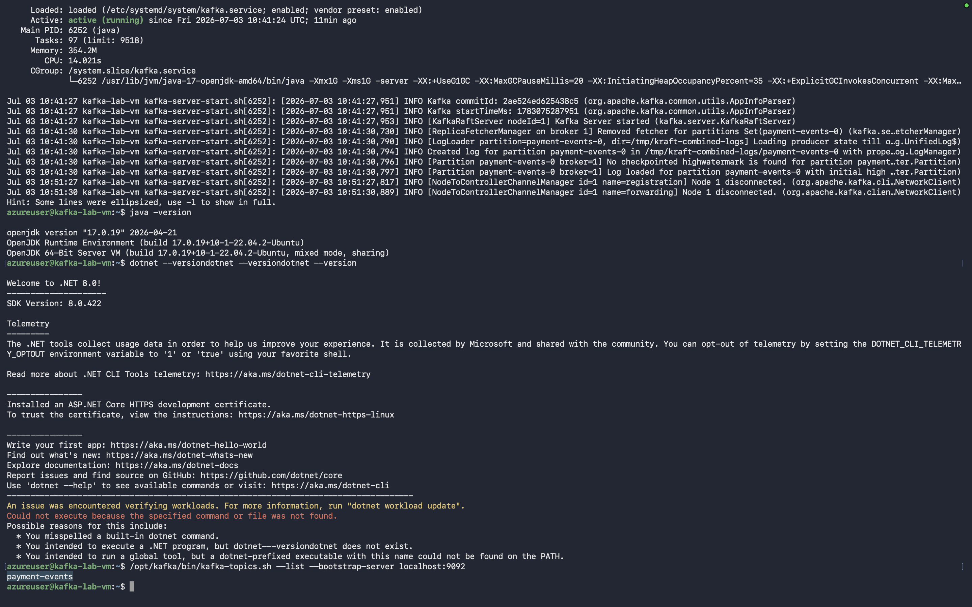

REFLECTION QUESTIONS
1. What does loadTextContent('setup.sh') do in the Bicep template? When does it run?
loadTextContent('setup.sh') reads the contents of the setup.sh file and includes it in the Bicep template during deployment
2. What is the role of the Custom Script Extension? How does Azure know what to run?
The Custom Script Extension runs a script on the Azure VM, and Azure knows what to run from the command specified in the extension settings.

3. Why does KRaft mode need kafka-storage.sh format to run before Kafka can start?
KRaft mode needs kafka-storage.sh format to initialize the Kafka storage before the broker can start.

Part 2: Build the PaymentProcessor WebAPI
This WebAPI acts as a mock payment gateway. It receives a payment request, randomly approves (~70%) or declines (~30%) it, publishes the result to Kafka, and returns a JSON response.

Step 2.1 — Create the WebAPI Project

BASH (SSH — Linux VM)
cd ~
dotnet new webapi -n PaymentProcessor --no-https
cd PaymentProcessor
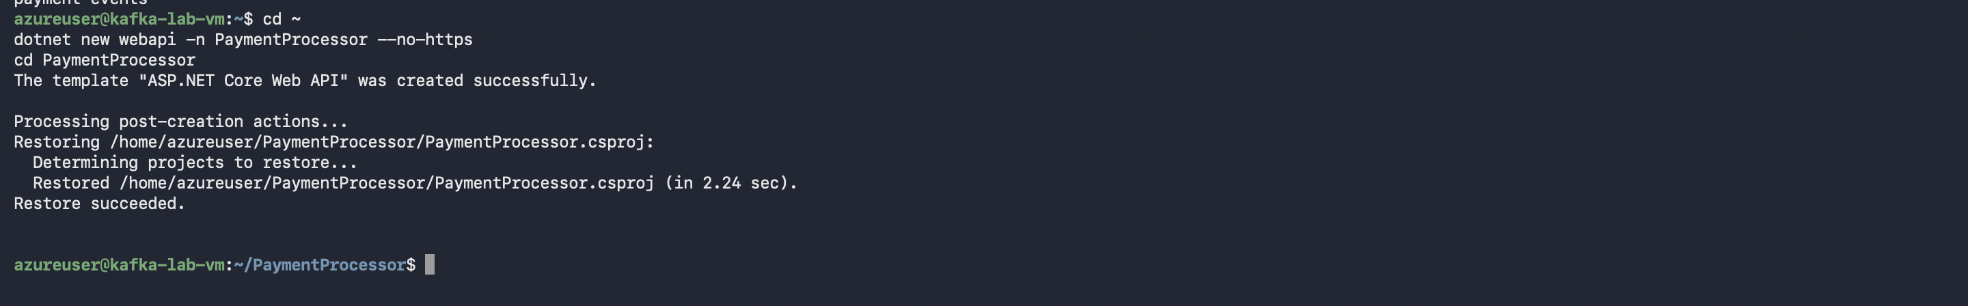

Step 2.2 — Add Confluent.Kafka Package

BASH (SSH — Linux VM)
dotnet add package Confluent.Kafka
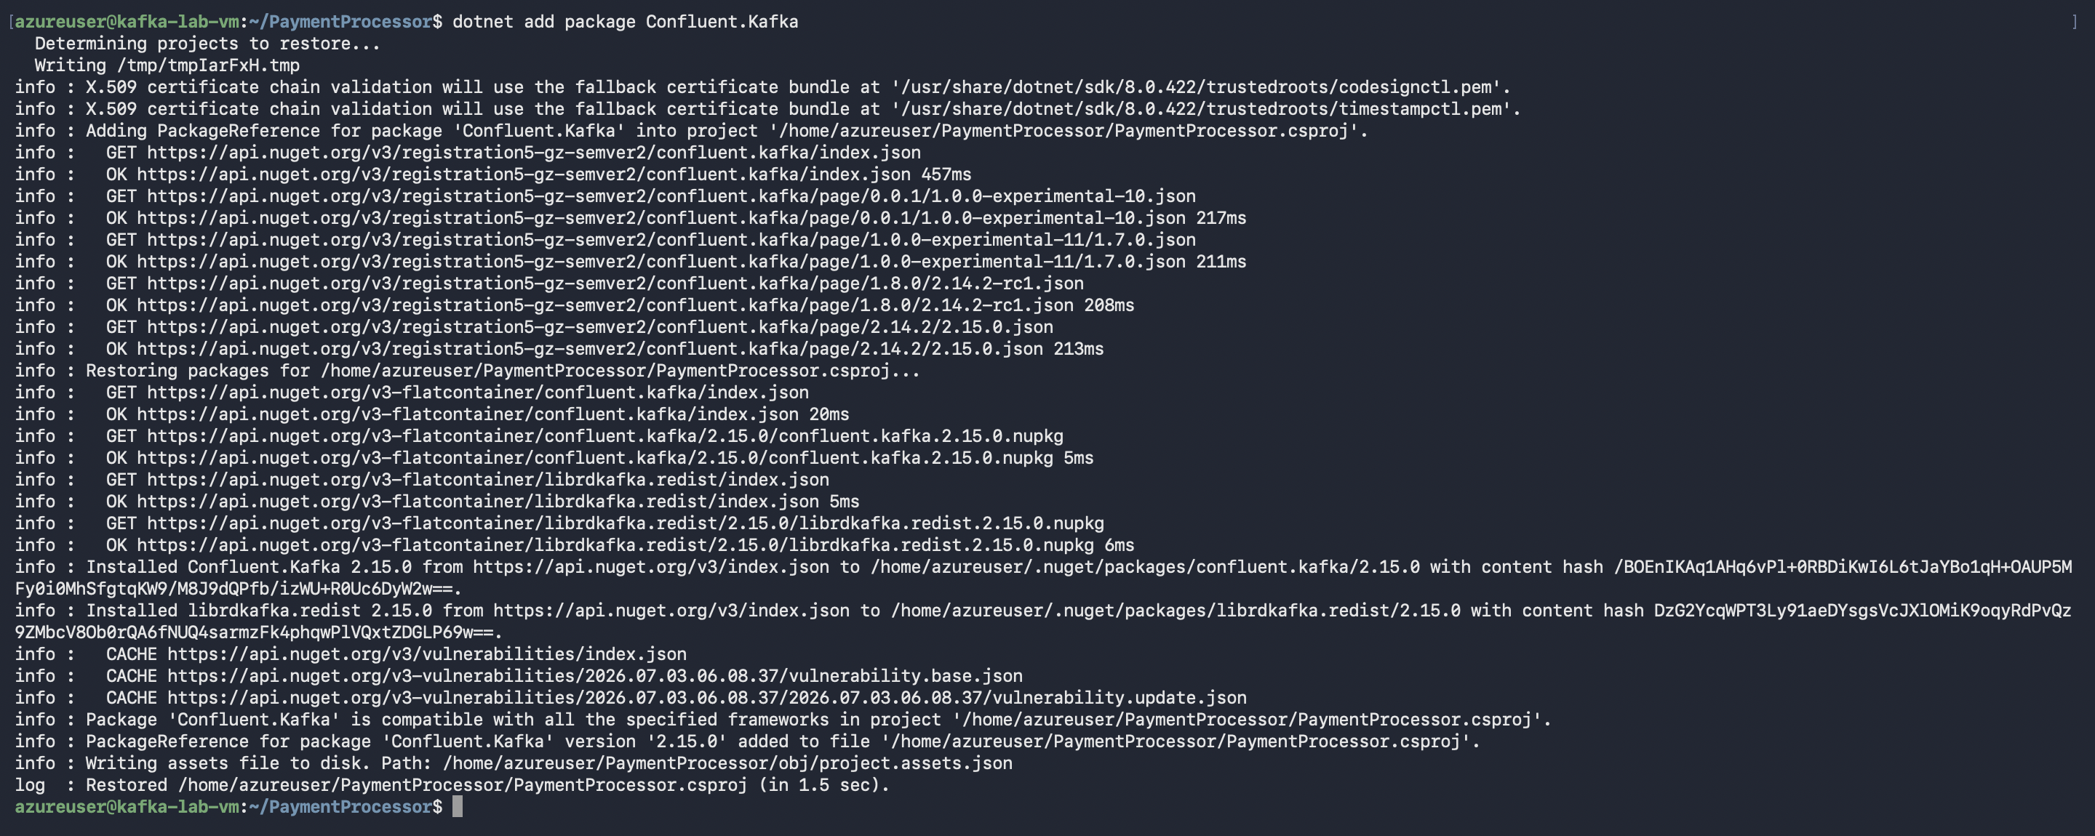

Step 2.3 — Create the Models

BASH (SSH — Linux VM)
mkdir -p Models

cat > Models/PaymentRequest.cs << 'EOF'
namespace PaymentProcessor.Models;

public class PaymentRequest
{
public string TransactionId { get; set; } = string.Empty;
public string MerchantName { get; set; } = string.Empty;
public decimal Amount { get; set; }
public string CardLastFour { get; set; } = string.Empty;
}
EOF

cat > Models/PaymentResult.cs << 'EOF'
namespace PaymentProcessor.Models;

public class PaymentResult
{
public string TransactionId { get; set; } = string.Empty;
public string MerchantName { get; set; } = string.Empty;
public decimal Amount { get; set; }
public string CardLastFour { get; set; } = string.Empty;
public string Status { get; set; } = string.Empty;
public string Reason { get; set; } = string.Empty;
public DateTimeOffset Timestamp { get; set; }
}
EOF
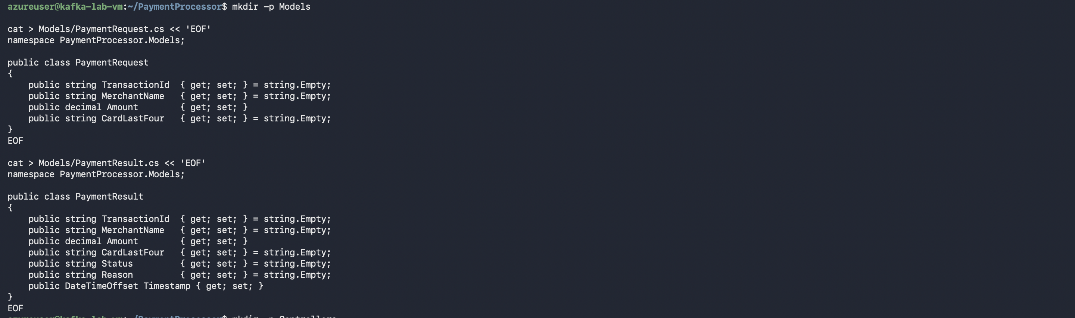

Step 2.4 — Create the Payment Controller

BASH (SSH — Linux VM)
mkdir -p Controllers

cat > Controllers/PaymentController.cs << 'EOF'
using Confluent.Kafka;
using Microsoft.AspNetCore.Mvc;
using PaymentProcessor.Models;
using System.Text.Json;

namespace PaymentProcessor.Controllers;

[ApiController]
[Route("api/[controller]")]
public class PaymentController : ControllerBase
{
private readonly IProducer<string, string> _producer;

private static readonly string[] DeclineReasons =
{
"Insufficient funds",
"Card blocked by issuer",
"Suspected fraud - unusual activity",
"Daily transaction limit exceeded",
"Card expired"
};

public PaymentController(IProducer<string, string> producer)
=> _producer = producer;

[HttpPost("process")]
public async Task<IActionResult> ProcessPayment([FromBody] PaymentRequest req)
{
var rng = new Random();
var approved = rng.Next(0, 10) > 2; // ~70% approval rate

var result = new PaymentResult
{
TransactionId = req.TransactionId,
MerchantName = req.MerchantName,
Amount = req.Amount,
CardLastFour = req.CardLastFour,
Status = approved ? "APPROVED" : "DECLINED",
Reason = approved ? "Payment authorised"
: DeclineReasons[rng.Next(DeclineReasons.Length)],
Timestamp = DateTimeOffset.UtcNow
};

await _producer.ProduceAsync("payment-events",
new Message<string, string>
{
Key = result.TransactionId,
Value = JsonSerializer.Serialize(result)
});

return Ok(result);
}

[HttpGet("health")]
public IActionResult Health()
=> Ok(new { status = "OK", time = DateTimeOffset.UtcNow });
}
EOF
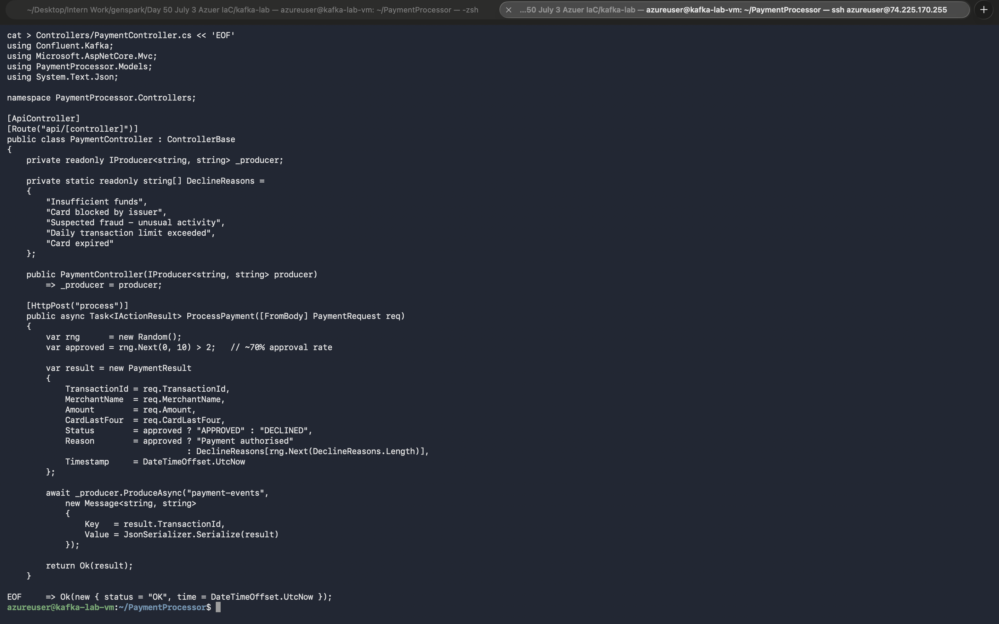

Step 2.5 — Replace Program.cs

BASH (SSH — Linux VM)
cat > Program.cs << 'EOF'
using Confluent.Kafka;

var builder = WebApplication.CreateBuilder(args);
builder.Services.AddControllers();

var producerConfig = new ProducerConfig { BootstrapServers = "localhost:9092" };
builder.Services.AddSingleton<IProducer<string, string>>(
new ProducerBuilder<string, string>(producerConfig).Build());

var app = builder.Build();
app.MapControllers();
app.Run("http://localhost:5100");
EOF
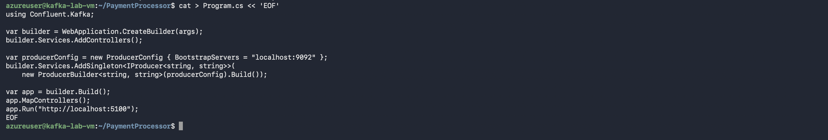

Step 2.6 — Remove Default Template Files

BASH (SSH — Linux VM)
rm -f WeatherForecast.cs Controllers/WeatherForecastController.cs

Step 2.7 — Build and Run

BASH (SSH — Linux VM)
dotnet run

You should see:

Expected Output
Building...
info: Microsoft.Hosting.Lifetime[14]
Now listening on: http://localhost:5100
info: Microsoft.Hosting.Lifetime[0]
Application started. Press Ctrl+C to shut down.

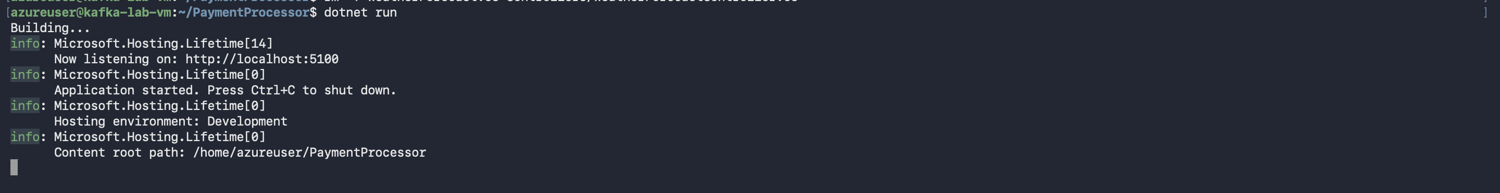

INFO
Leave this terminal running. The WebAPI must stay active for Part 3.
You will open a NEW SSH session for the console app.

REFLECTION QUESTIONS
1. Why is IProducer<string, string> registered as a Singleton (not Scoped or Transient)?
IProducer<string, string> is registered as a Singleton because one producer instance can be shared by the whole application
2. What do the two type parameters of IProducer<string, string> represent?
The first string is the message key, and the second string is the message value.

3. The controller writes to Kafka after determining the result. Why might a real system
A real system may write to Kafka first to make sure the event is safely recorded before responding.
4. write to Kafka BEFORE sending the HTTP response?
Writing to Kafka before the HTTP response helps prevent data loss and ensures other services can process the event.

Part 3: Build the PaymentSimulator Console App
The simulator has two concurrent tasks running in parallel. One task sends a payment request to the WebAPI every 3 seconds. The other task listens on the Kafka topic and prints each payment result as it arrives — in real time.

Step 3.1 — Open a Second SSH Session
Leave the WebAPI terminal open. Open a new Command Prompt window on your machine and SSH in again:

CMD (Windows Command Prompt)
ssh %ADMIN_USER%@%VM_IP%

(If %VM_IP% is no longer set, re-run the capture command from Step 1.7)

Step 3.2 — Create the Console Project

BASH (SSH — Linux VM)
cd ~
dotnet new console -n PaymentSimulator
cd PaymentSimulator
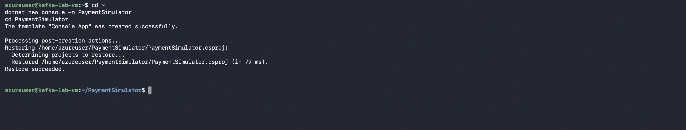

Step 3.3 — Add Confluent.Kafka Package

BASH (SSH — Linux VM)
dotnet add package Confluent.Kafka
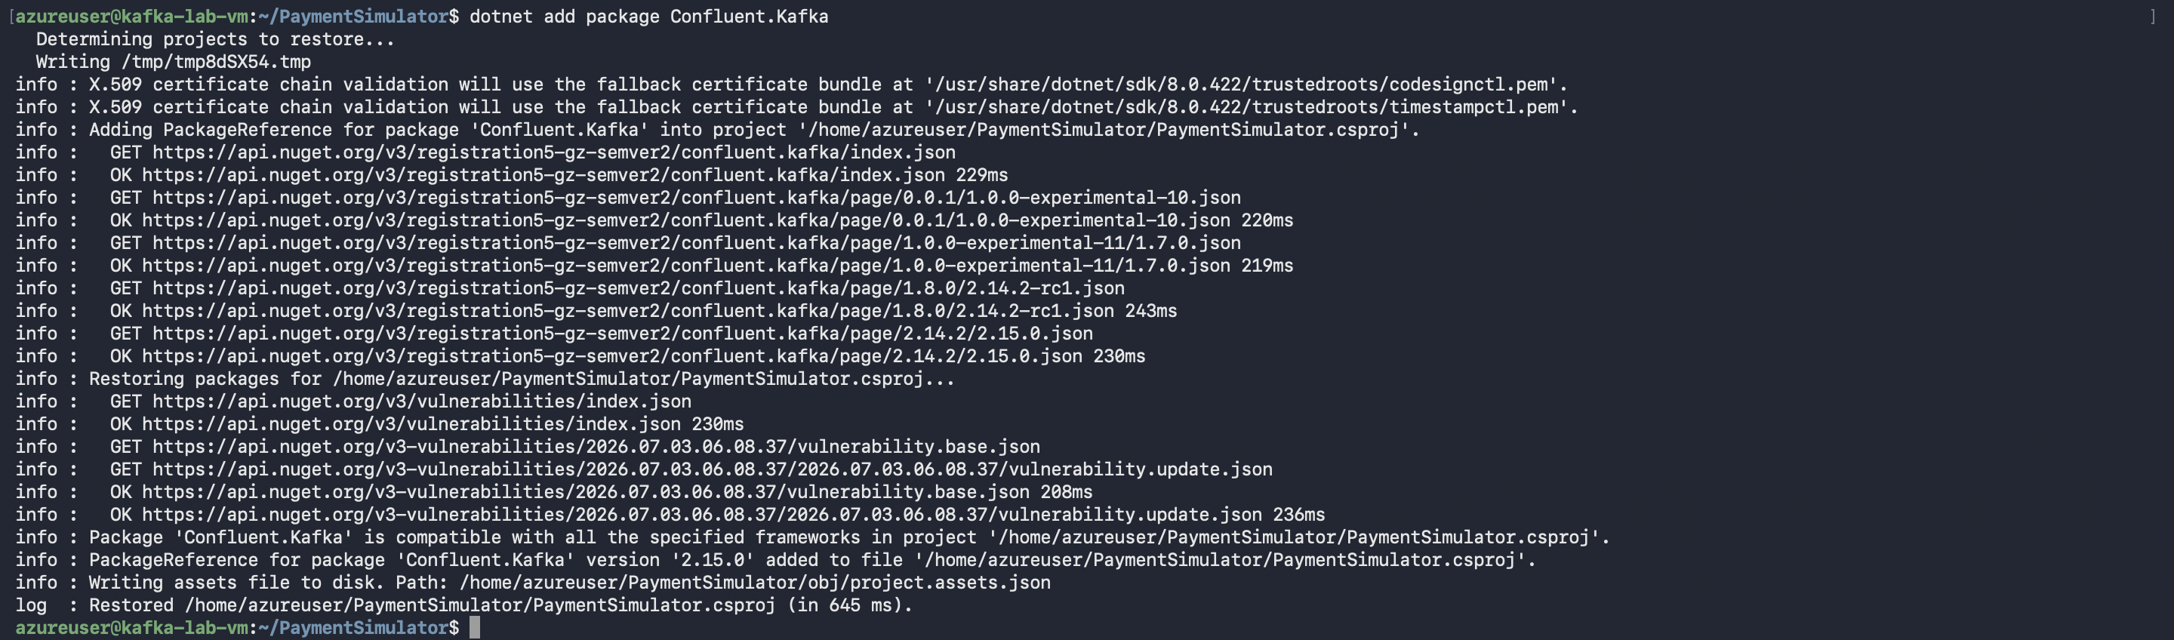

Step 3.4 — Replace Program.cs

BASH (SSH — Linux VM)
cat > Program.cs << 'EOF'
using Confluent.Kafka;
using System.Net.Http.Json;
using System.Text.Json;

const string WebApiUrl = "http://localhost:5100";
const string KafkaBoot = "localhost:9092";
const string TopicName = "payment-events";

string[] Merchants = { "Amazon UK", "Tesco Online", "Netflix",
"Uber Eats", "Sainsburys", "ASOS", "Spotify" };
string[] Cards = { "4242", "1234", "5678", "9999", "0011" };

var cts = new CancellationTokenSource();
var httpClient = new HttpClient { BaseAddress = new Uri(WebApiUrl) };
var rng = new Random();
int counter = 0;

Console.CancelKeyPress += (_, e) => { e.Cancel = true; cts.Cancel(); };

// ── Kafka Consumer (background) ─────────────────────────────────
var consumerTask = Task.Run(() =>
{
var cfg = new ConsumerConfig
{
BootstrapServers = KafkaBoot,
GroupId = "payment-simulator-group",
AutoOffsetReset = AutoOffsetReset.Latest
};
using var consumer = new ConsumerBuilder<string, string>(cfg).Build();
consumer.Subscribe(TopicName);

Console.ForegroundColor = ConsoleColor.Cyan;
Console.WriteLine($"[Consumer] Subscribed to '{TopicName}'. Waiting...\n");
Console.ResetColor();

while (!cts.Token.IsCancellationRequested)
{
try
{
var cr = consumer.Consume(TimeSpan.FromSeconds(1));
if (cr is null) continue;

var r = JsonSerializer.Deserialize<PaymentResult>(
cr.Message.Value,
new JsonSerializerOptions { PropertyNameCaseInsensitive = true })!;

Console.ForegroundColor = r.Status == "APPROVED"
? ConsoleColor.Green : ConsoleColor.Red;

Console.WriteLine(
$" {(r.Status == "APPROVED" ? "[OK]" : "[--]")} " +
$"[{r.Timestamp:HH:mm:ss}] {r.TransactionId} " +
$"{r.MerchantName,-16} £{r.Amount,7:F2} " +
$"****{r.CardLastFour} {r.Status,-8} {r.Reason}");

Console.ResetColor();
}
catch (ConsumeException ex)
when (!cts.Token.IsCancellationRequested)
{
Console.Error.WriteLine($"[Consumer error] {ex.Error.Reason}");
}
}
consumer.Close();
});

await Task.Delay(2000);

Console.ForegroundColor = ConsoleColor.Yellow;
Console.WriteLine("==============================================");
Console.WriteLine(" Payment Simulator -- Real-Time Feed ");
Console.WriteLine("==============================================\n");
Console.ResetColor();
Console.WriteLine("Sending one payment every 3 seconds. Ctrl+C to stop.\n");

// ── HTTP Producer loop ───────────────────────────────────────────
while (!cts.Token.IsCancellationRequested)
{
var req = new {
transactionId = $"TXN{++counter:D6}",
merchantName = Merchants[rng.Next(Merchants.Length)],
amount = Math.Round((decimal)(rng.NextDouble() * 249 + 1), 2),
cardLastFour = Cards[rng.Next(Cards.Length)]
};

Console.ForegroundColor = ConsoleColor.DarkYellow;
Console.WriteLine($"-> [{DateTime.UtcNow:HH:mm:ss}] {req.transactionId} " +
$"{req.merchantName,-16} £{req.amount:F2} ****{req.cardLastFour}");
Console.ResetColor();

try { await httpClient.PostAsJsonAsync("/api/payment/process", req, cts.Token); }
catch (Exception ex) when (!cts.Token.IsCancellationRequested)
{ Console.Error.WriteLine($"[HTTP error] {ex.Message}"); }

await Task.Delay(3000).ContinueWith(_ => { });
}

await consumerTask;
Console.WriteLine("\nSimulator stopped.");

record PaymentResult(string TransactionId, string MerchantName,
decimal Amount, string CardLastFour, string Status,
string Reason, DateTimeOffset Timestamp);
EOF

Step 3.5 — Run the Simulator

BASH (SSH — Linux VM)
dotnet run

You will see outbound arrows (->) as payments are sent, and [OK]/[--] lines as results arrive from Kafka:

Expected Output (approximate)
==============================================
Payment Simulator -- Real-Time Feed
==============================================

[Consumer] Subscribed to payment-events. Waiting...

-> [14:23:01] TXN000001 Amazon UK £127.45 ****4242
-> [14:23:04] TXN000002 Netflix £89.99 ****1234

[OK] [14:23:01] TXN000001 Amazon UK £127.45 ****4242 APPROVED Payment authorised
[--] [14:23:04] TXN000002 Netflix £89.99 ****1234 DECLINED Insufficient funds

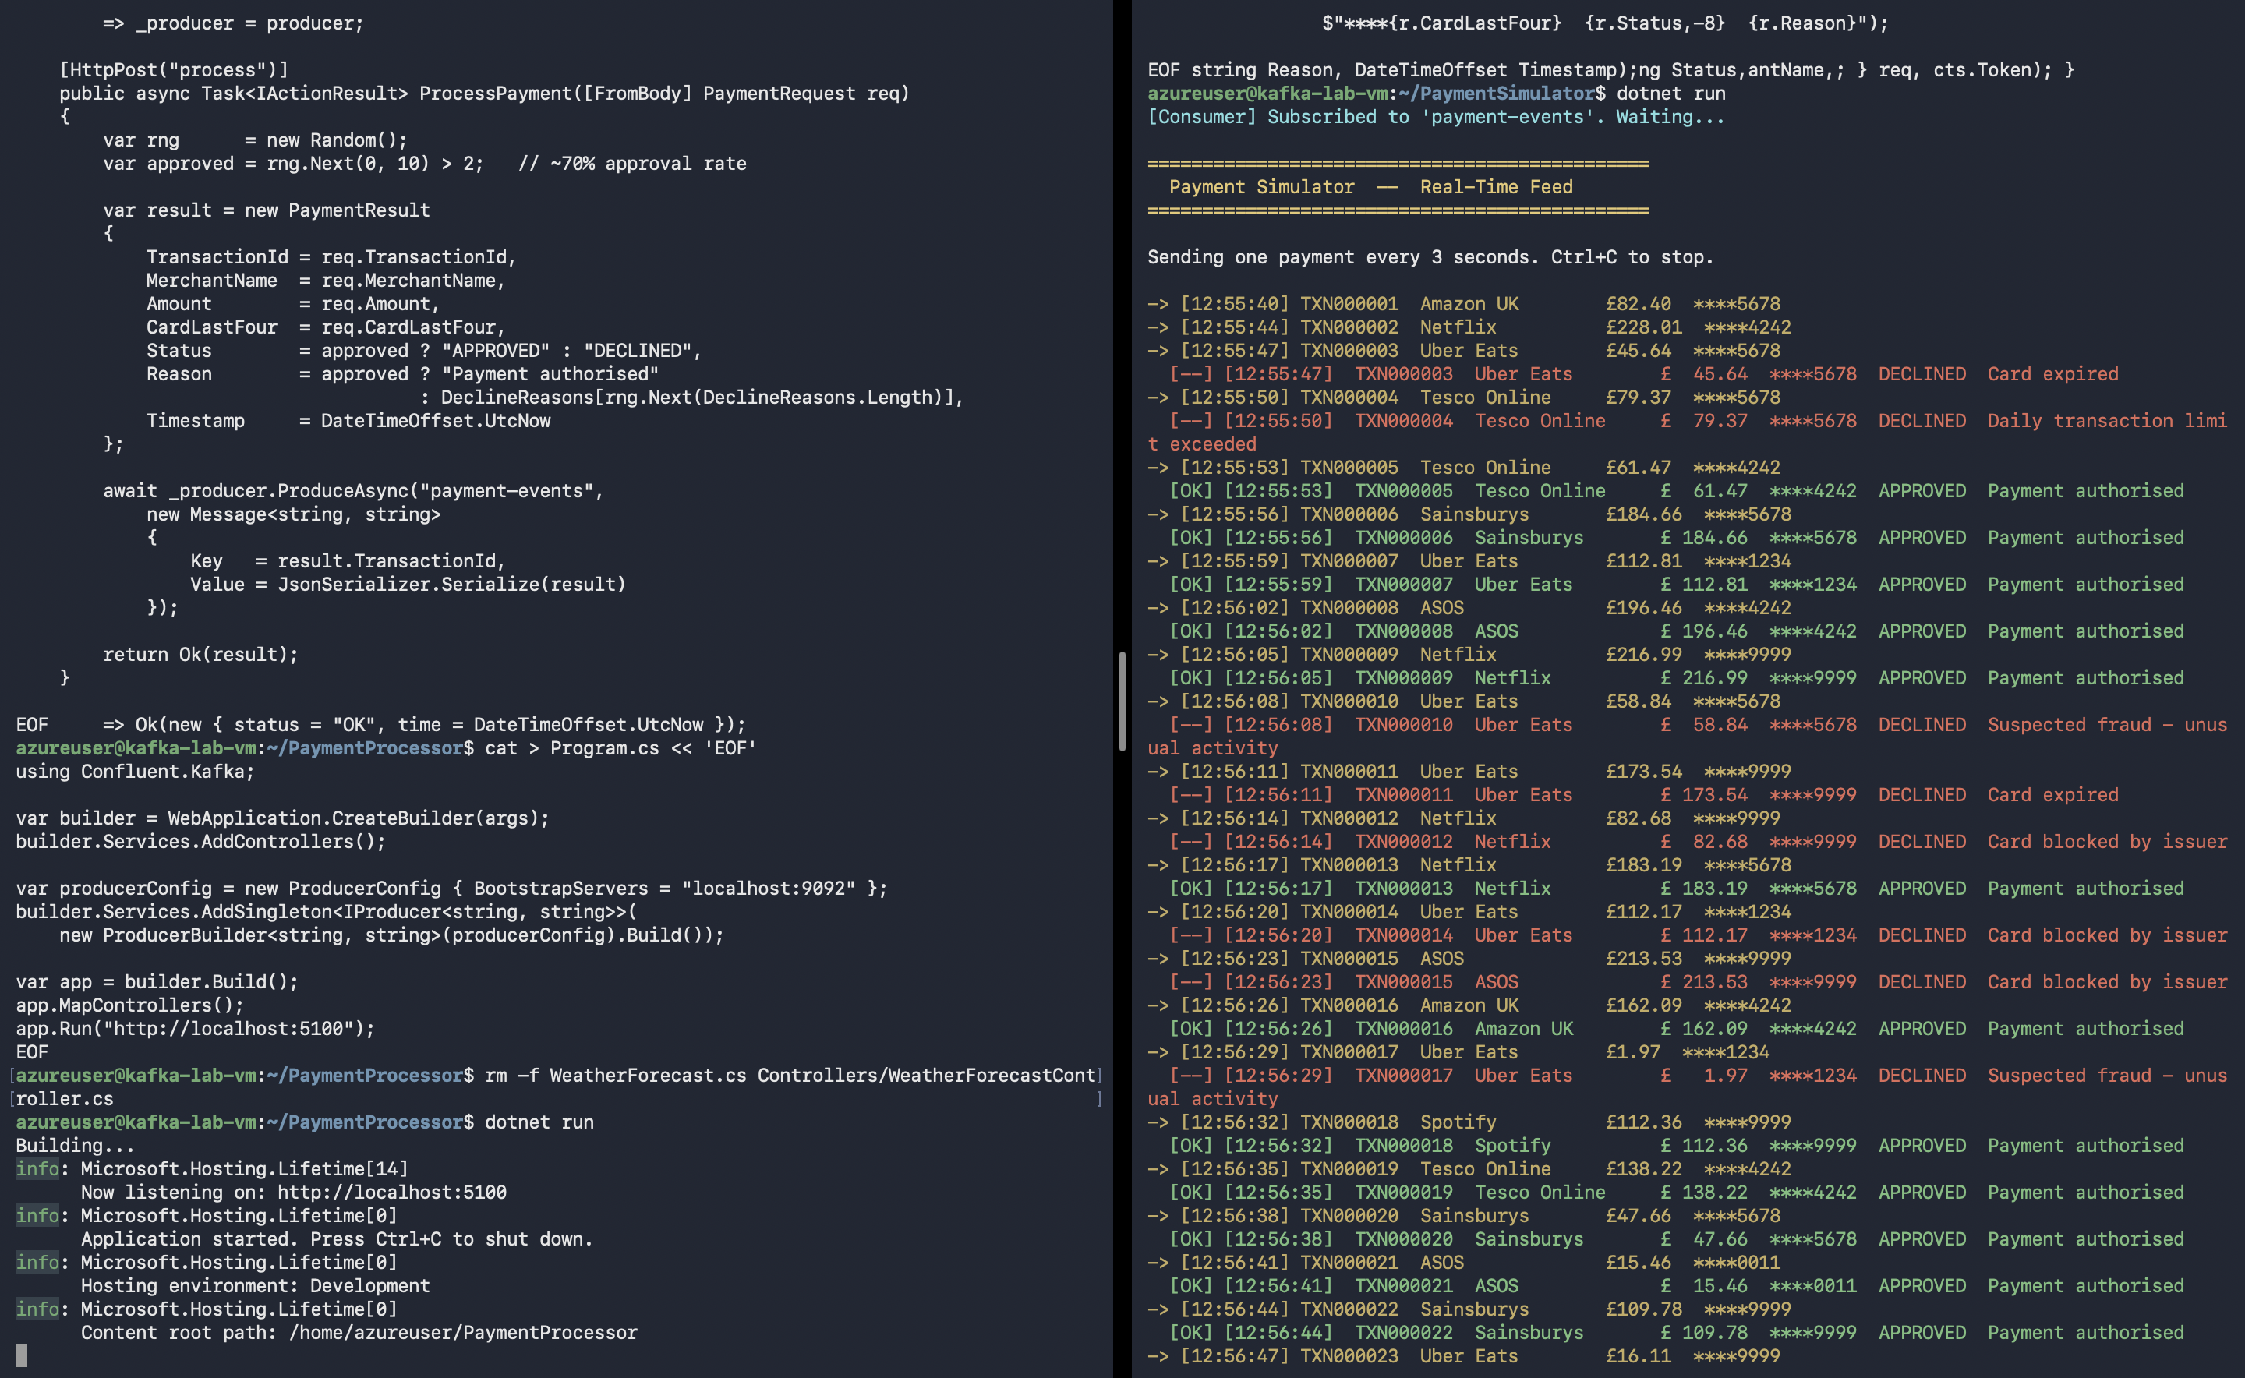

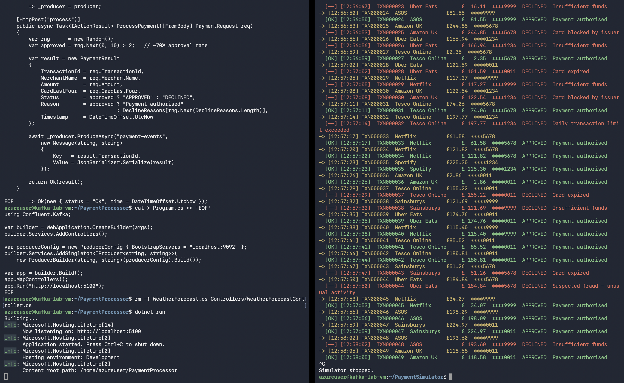

REFLECTION QUESTIONS
1. Why does the [OK] / [--] result appear slightly after the -> sending line?
__because Kafka processes the message in the background after it is sent.
2. What does AutoOffsetReset.Latest mean? What would happen if you used Earliest instead?
AutoOffsetReset.Latest reads only new messages, while Earliest reads all old messages from the beginning
3. If you stopped the WebAPI and restarted it while the simulator was running,
it reconnects to Kafka and continues consuming messages
4. what would you expect to see? What does this tell you about Kafka vs a direct API call?
Kafka stores messages, so they are not lost if the WebAPI is down, unlike a direct API call which would fail.
5. In a real payment system, what downstream services might consume from this same topic?
Services like billing, fraud detection, notifications, reporting, and analytics can consume the same Kafka topic.

Common Errors & Fixes

Error / Symptom | Cause | Fix
kafka-topics.sh: Connection refused | Kafka not started or JAVA_HOME missing | Run: export JAVA_HOME=/usr/lib/jvm/java-17-openjdk-amd64 Then: systemctl restart kafka Wait 15s and retry
Deployment extension shows Failed in portal | setup.sh errored during deployment | SSH in and run: cat /var/log/kafka-setup.log Find the last error line and fix
dotnet: command not found | .NET SDK not yet installed (deployment still running) | Run: tail -f /var/log/kafka-setup.log Wait for "Setup Complete" then retry
HTTP error: Connection refused in simulator | WebAPI not running or wrong port | Confirm terminal 1 shows "Listening on http://localhost:5100"
InvalidTemplateDeployment on az deployment create | setup.sh not in same folder as main.bicep | Both files must be in %USERPROFILE%\kafka-lab. Run the deploy command from that folder
Kafka service: failed (Exit code 1) | Storage not formatted before first start | Run: journalctl -u kafka -n 20 --no-pager Re-run kafka-storage.sh format if needed

Cleanup
When you are finished, stop the applications and delete all Azure resources:

Stop the Applications

BASH (SSH — Linux VM)
# In each SSH terminal, press Ctrl+C to stop the running app, then:
exit

Delete All Azure Resources

CMD (Windows Command Prompt)
az group delete --name %RG% --yes --no-wait
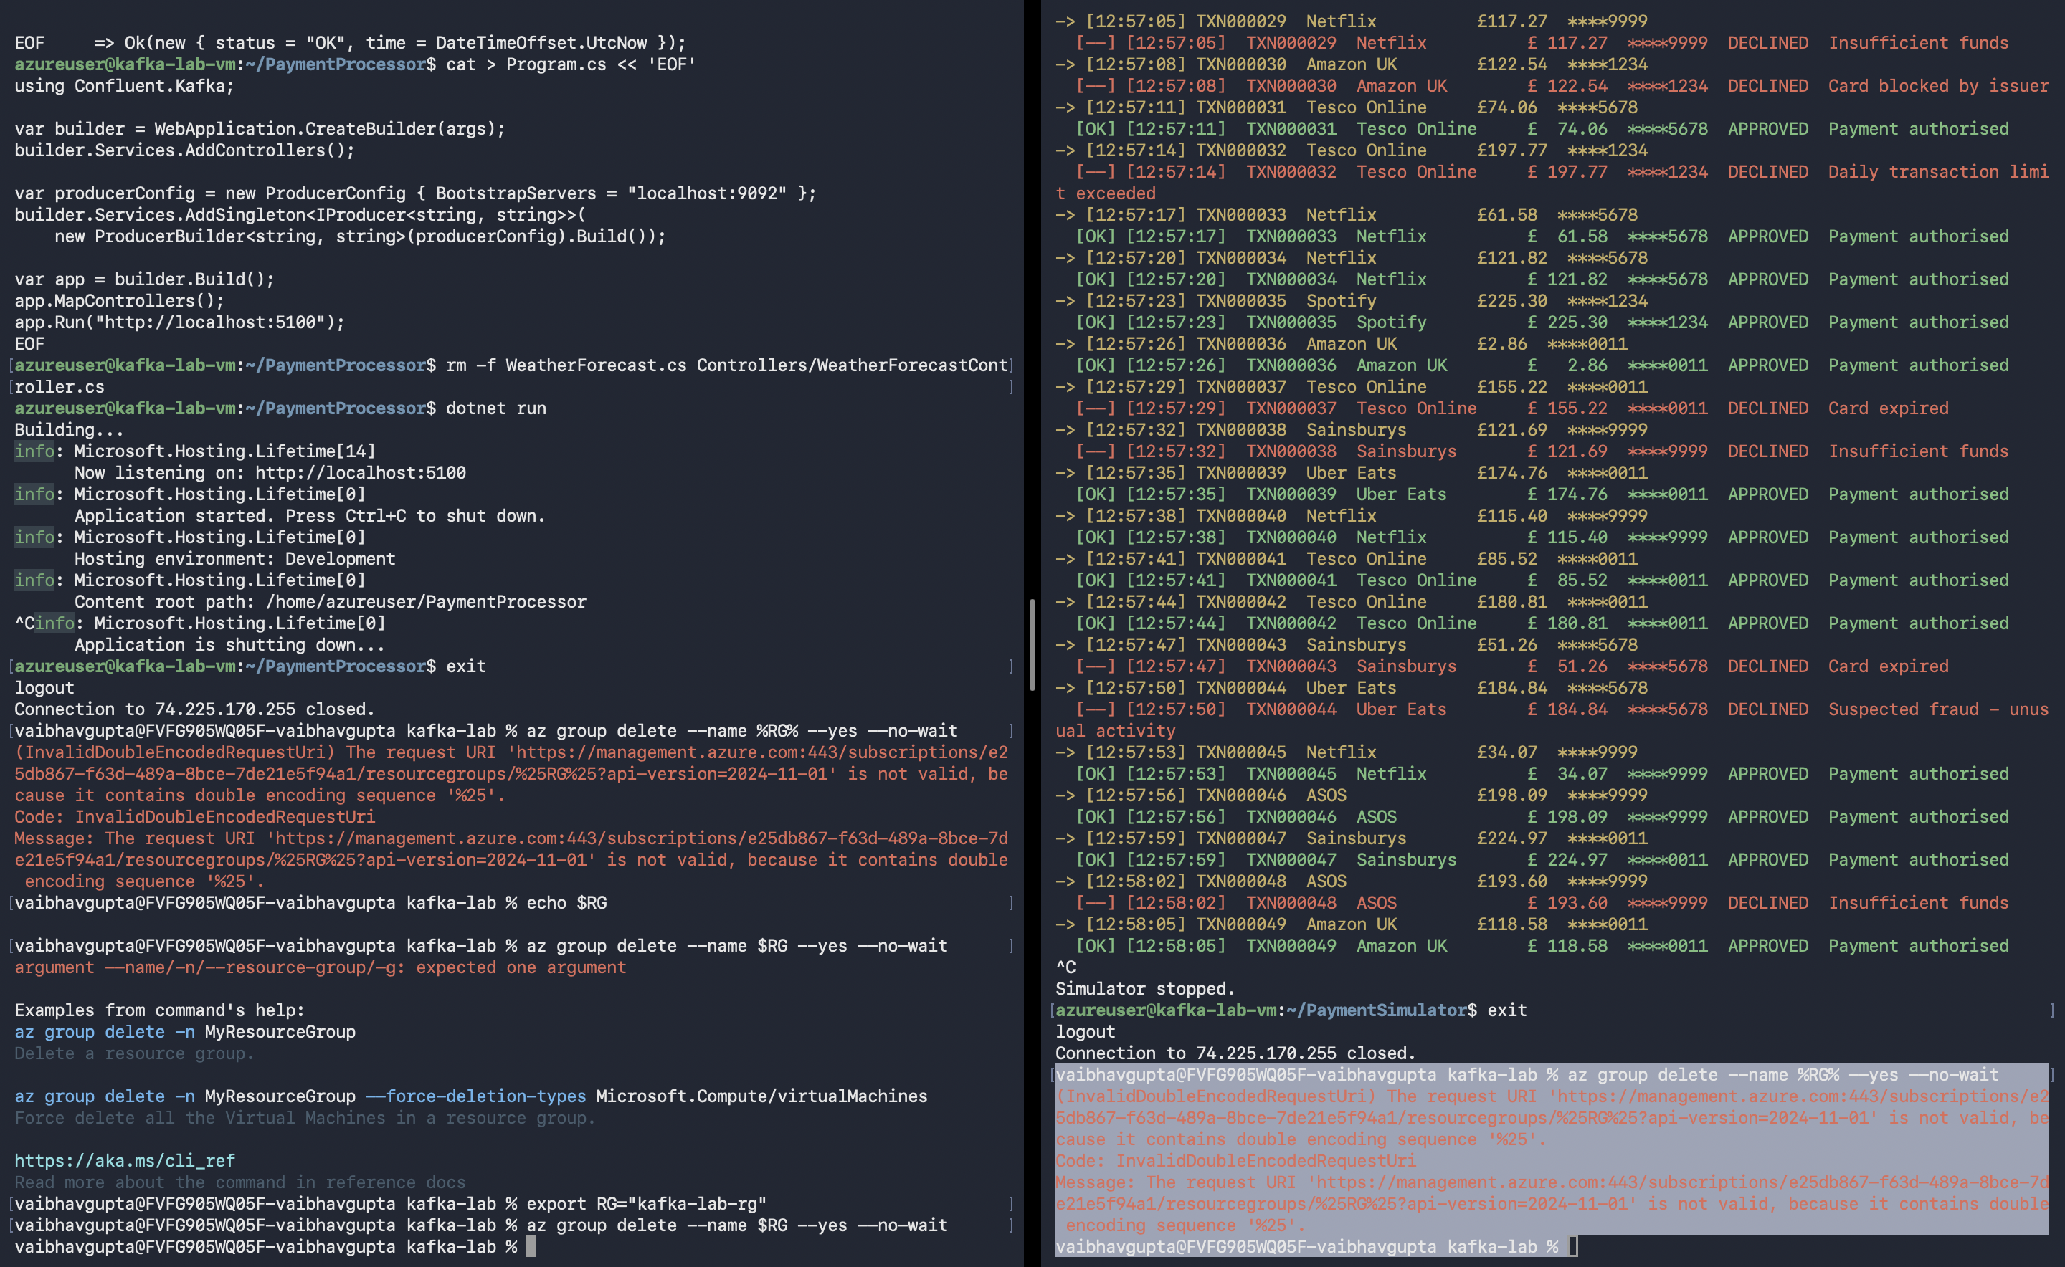
INFO
This deletes the VM, disk, NIC, public IP, VNet, and NSG in one command.
The Standard_B2ms VM costs approximately $0.095/hour while running.
Always delete the resource group at the end of the lab to avoid unexpected charges.

To confirm deletion is complete (takes ~2-3 minutes):
az group show --name kafka-lab-rg
Should return "ResourceGroupNotFound" once finished.

What You Built
- A Bicep template that provisions a complete VM environment with zero manual installation.
- An Apache Kafka broker running in KRaft mode (no ZooKeeper) as a managed Linux service.
- A .NET 8 WebAPI (PaymentProcessor) that acts as a Kafka producer.
- A .NET 8 console app (PaymentSimulator) with concurrent producer and consumer threads.
- A real-time event streaming pipeline — the foundation of modern payment and notification systems.

